The Noor Solar Plant, Morocco
The Noor solar plant aims to replace fossil fuels as the major form of electricity production in a country where sunlight is in abundance. It is the first of four sites spread across the country that are to be developed.
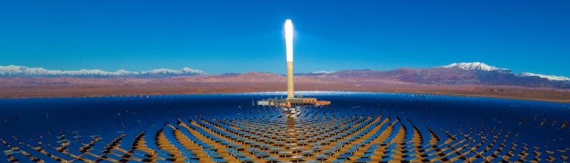
Noor factbox
- The Noor solar farm is located near Ouarzazate at the northern edge of the Sahara Desert.
- At 510MW and covering an area of over 3,000ha, Noor is one of the largest solar farms in the world.
- Land that previously had no economic value is now used to generate electricity.
- The high angle of the sun at this latitude results in highly concentrated sunshine.
- Noor 1-111 (2016-18) uses parabolic panels; Noor1V (2018) uses photovoltaic cells.
- Noor can store heat during the day in salt which can be released to generate electricity even when the sun is not shining (at night).
- Morocco aims to produce 52% of its electricity from solar power by 2030.
- Morocco is able to export electricity using high-voltage direct current cables (HVDC). Xlinks is proposing a direct link from Morocco to Alverdiscott, North Devon with 4 HVDC cables (2,400 miles in length) which could provide up to 8% of the UK’s energy needs.
- Construction employed 7,000 people. 500 permanent jobs have been created. Ouarzazate is now an international centre for research into solar energy.
- Similar potential exists throughout the desert lands to produce clean energy especially for local use.

