Survey Point | Location | Temperature (ºC) | Wind Direction (compass direction) | Wind Speed (km/h) | Cloud Cover (eighths)
1 | Front Yard
2 | Front Yard
3 | Front Yard
4 | Courtyard
5 | Courtyard
6 | Courtyard
7 | Back Yard
8 | Back Yard
9 | Back Yard
Investigation Structure
- Describe what you are going to do to conduct the fieldwork

- State the aim of your investigation
- State the geographical enquiry question of your investigation
- Identify the advantages & disadvantages of the location
- Select the sampling method you are going to use
- On a map of the school site, using your sampling method, select survey points (in this example, 9 points were selected)
- Write a risk assessment for the fieldwork – ideally, do this in collaboration with pupils
- Record the weather at each survey point, using the categories on the data collection table (be aware of possible H&S issues)
- Chose a method of data collection, and present your data
- Describe your results
- Analyse the data using mean, media, mode and range
- Attempt to explain the links and anomalies of your results
- Make a conclusion
- Evaluate your fieldwork: what went well, even better if and improvements for next time
Selecting, Measuring and Recording Data

- What primary data should be collected?
Work with students to consider and plan:
  - How many survey points should be selected?
  - How will the survey points be chosen? Consider sampling options and pros and cons of different approaches.
  - How to measure microclimates? Which weather elements should be included? Why will some be left out?
  - When will the primary data be collected? Consider pros and cons of collecting data during a timetabled geography lesson

- Where should it be collected?
In most cases, sample points will need to be selected (stratified sampling) to ensure a variety of locations
  - Locate survey points on a base map of the school
  - Working in pairs, students make observations and record results from one or more site (consider H&S issues)
  - Take photo of each site
Data Presentation

Data presentation ideas:
- Bar graphs – simple and effective
- Located bar graphs (you will need another map of the school site) – this is probably the most effective and most appropriate technique to address the investigation question
- Isoline map – an ambitious option but can work well in showing patterns of temperature
- Weather Map – creating a weather map of the school, based on the idea of what the students would see on the tv or on their phone. This can be done by hand or using an app.

BBC Weather App

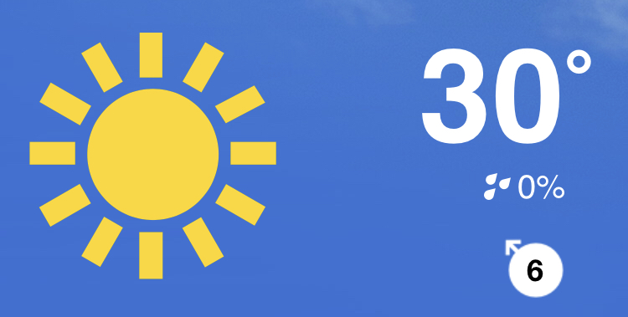

- The production of a summary labelled photo (see page 2)can work well as a collaborative exercise in presenting data and suggesting causal links (analysis).

School Microclimate Survey

Risk Assessment

Hazard and Risk | Who may be involved? | Level of risk | Precautions used to minimise risk and why they are used
Equipment | Students | Medium | Check that you have everything you need before you leave the classroom
Weather | Everyone | Medium  (variable) | Check the weather forecast and wear appropriate clothes  Return if the weather changes significantly  Change the data collection day if the weather forecast is poor or unsuitable for study

Equipment

Data collection sheet Thermometer Camera
Pen Anemometers
Map of school site Wind vane

Location

- Assess the suitability of the choice of fieldwork location (advantages; link to aims; disadvantages)
Advantages of school site:
- Cost – you do not have to pay for transport or cover teachers
- Distance – data can be collected during a lesson
- Safe – there are no risks associated with fieldwork outside the school grounds
Disadvantages of school site:
- Not testing a range of places – rules out a comparison with another site e.g. town centre or outside the local shop, although this could be considered as a follow-up exercise
- Time of day/year will have effect on results, e.g. a lesson after lunch will probably be universally warmer than one at the start of the day

Focus of Geographical Enquiry
- State the aim of your geographical enquiry
To investigate microclimate around the school site

- State the geographical enquiry question
How does microclimate vary around the school site?

(See YouTube video produced by the FSC on ‘Weather and climate’ at
https://www.youtube.com/watch?v=aeGKsE77vE0)
Data Processing and Presentation (cont.)

- Discuss with students the effectiveness of the chosen presentation technique. Consider the accuracy, ease of interpretation, ability to refer to actual figures, clarity, etc. Was the technique appropriate for answering the investigation question? Any problems with the technique?
- Could the technique be improved or, on reflection, should an alternative method have been used?

EXAMPLE

Located bars (columns)
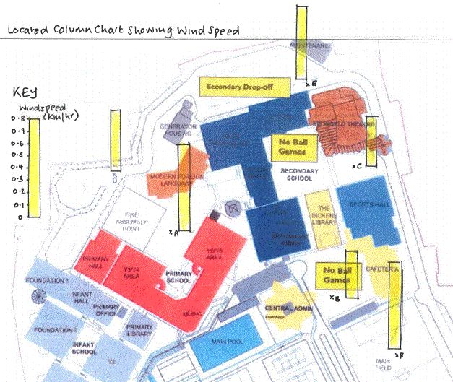
https://www.jkgeography.com/microclimates.html

Advantages:
- Presents precise data recorded
- Shows the location of each survey point, enabling causal links to be suggested
- Data values can be given with precision using the scale
- Can be used in combination with other maps, such as isolines
- Effective and immediate visual representation of data

Disadvantages
- Some students may find it difficult to construct bars accurately – best done on graph paper and cut out
- Locating bars can be an issue, as they may overlap each other. Use a clear dot to indicate the survey point location (on base map).

It’s important that students assess the success of data presentation techniques, learning lessons for future scenarios.
Conclusions
- What can you conclude from your results? (use evidence to support your conclusion and refer to the aim of the investigation)

For example, students could choose one of the following statements

- My investigation showed that microclimate did vary round the school site
- My investigation showed that microclimate did not vary around the school site

Once the students have chosen one of the statements, they need to refer to evidence that supports their statement. They could make links between different surfaces, the proximity to buildings, the time of day, the season (do students go out more in the summer rather than the winter?)
The strength (reliability) of the conclusion should be considered too.

Photo, satellite photo or school plan

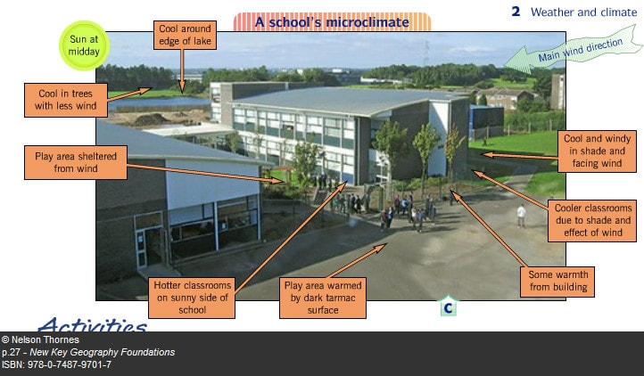
https://www.jkgeography.com/microclimates.html
School Site Microclimate Survey

Evaluation

- What went well with your investigation?
How might the study vary according to different weather conditions?
How might the study vary with different times of the day/year?
How might the study vary with different locations and sampling strategy?

- What could have gone better with your investigation?
How could data collection be improved?
Would this affect the accuracy of results and reliability of conclusions?
Would you expect to find similar results in other school sites?

- What would you do differently if you were to do the investigation again?
Would you use the same survey points?
Would you change the time of day you did the survey?
Would you use the same sampling methods?
Would you use the same data presentation methods?

The key thing here is to encourage positive criticism and to consider how a similar study could be done even better in the future
Description, Analysis & Explanation of Results

- Describe what your results show (what is the overall trend?)
Identify the site where there is the highest and lowest temperature, wind speed, etc

- Analyse what your results show (use statistical techniques to provide precise information))
Consider using statistical skills such as mean, median and range. For some students, it might be possible to introduce percentage (e.g. 60% of the sample sites had a temperature of above 20ºc)

- Explain what your results show (give reasons/meanings for your findings)
Why did certain results occur at certain survey points? Consider the role of surface types (e.g. grass, tarmac) and proximity to buildings and heat sources.
- Can you explain any links between datasets?
For example, wind tunnels will affect wind speed and wind direction
Places where there is a lot of shade - will this affect temperature?
- Can you identify any anomalies in your results? Can you suggest reasons for this? How could any anomalies impact upon the reliability of conclusions?
Are there any survey points that had a high score (e.g. a micro heat island) but were expected to have a low score?

Are there any survey points that had a low score but were expected to have a high score?

