Exploring the Hydrology of Contrasting River Catchments

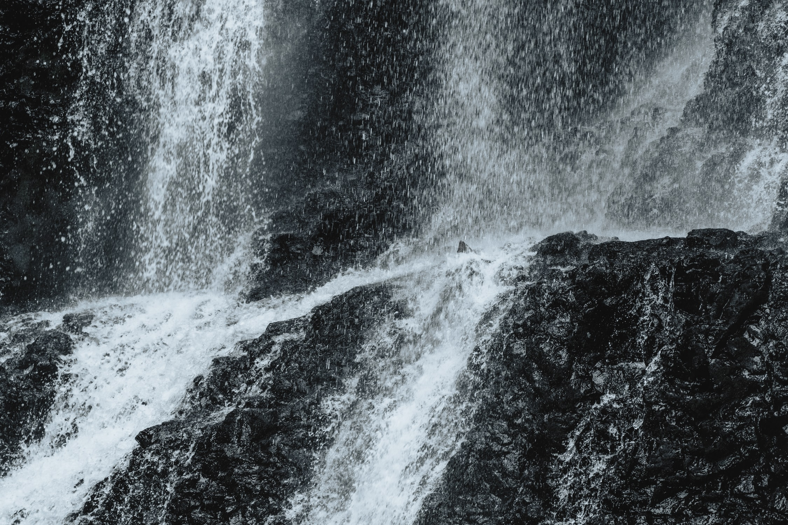

In many A-Level geography specifications reference is made to the water cycle, and the movement of water between the various different stores and the processes involved. It can be quite hard to conceptualise this at the global scale, and so one approach is to explore hydrology at the river catchment scale (a more relatable spatial unit). In hydrological research a common approach is to work with pairs of river catchments, especially when there is a series of a common characteristics (e.g. terrain, landcover, geology), and some which differ.

Below is a link to an ArcGIS Story Map which allows you to explore two catchments in England – the Ock and the Lambourn. These catchments are neighbours, and on the surface have very similar catchment characteristics. However their hydrology/flow regimes are very different in reality. This Story Map takes you through the characteristics of the catchments and allows you to interact with and explore their similarities and differences. Throughout are a number of GIS and practical exercises for students to engage with to build up an argument as to why these catchments look the same on the surface, but are really very different.

The blank student version of the Story Map can be found here: https://storymaps.arcgis.com/stories/aa2ef69bfc0f433cb802683ea4e60f87

The teacher version of the Story Map (with answers to the questions) can be found here: https://storymaps.arcgis.com/stories/5690e907c46340f8bc74dcab0461b96e

