Exploring River Catchments

(The River Exe, Devon)

In this GIS activity you will explore the characteristics of the River Exe catchment in the South West region.

Part 1: Accessing the Explore South West Data Explorer

- To access the Explore South West Data Explorer head to the Geography South West webpage: https://www.geographysouthwest.co.uk/explore-sw/.
- Click the map image to open the Explorer in a full screen new tab.
- You can change the basemap using the icon in the top right hand corner of the map.

- Change the basemap to ‘Topographic’.
- In the layers list (on the left hand side) tick the ‘Integrated Hydrological Units’ layer to turn this on. IHU’s are very similar conceptually to ‘river catchments’.

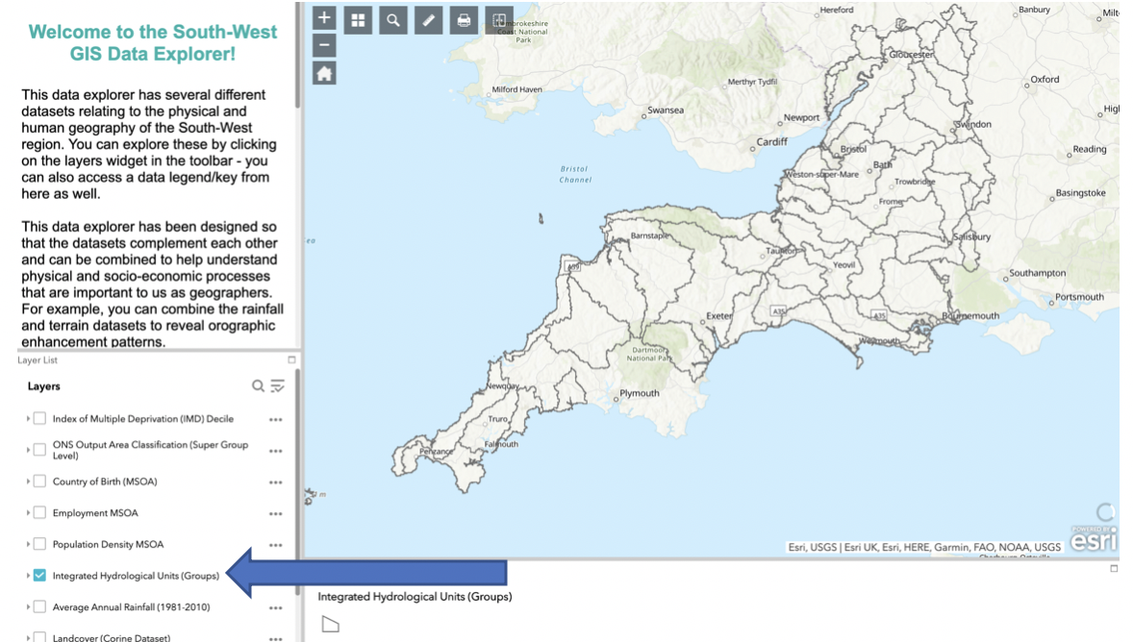

- Zoom into the Hydrological Unit/Group named ‘Exe (Source to Sea)’. This area generally represents the drainage area of the River Exe.
- Click on the ‘Search’ icon along the top of the screen. Search for the ‘River Exe’, and select the ‘River Exe’ under the heading ‘River Network’. Shown below:

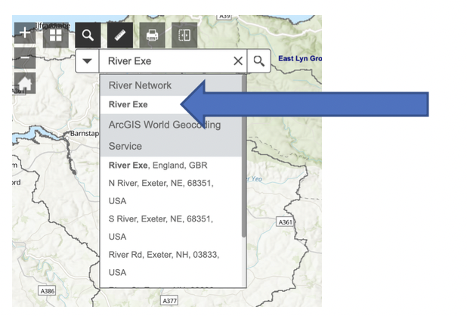

- The River Exe should now highlight in Blue. Now turn on the ‘Terrain’ layer, and fill in the blanks below.

The Source of the River Exe is in _____________________ National Park in the North of the catchment. This is the _________________ part of the catchment.

The Mouth of the River Exe is nearby the town of ______________________ in the South of the catchment. This is the _________________ part of the catchment.

**Hints: Lowest; Highest; Exmoor; Exmouth**

- Turn on the ‘Average Annual Rainfall’ layer. Your screen should like the screenshot below.

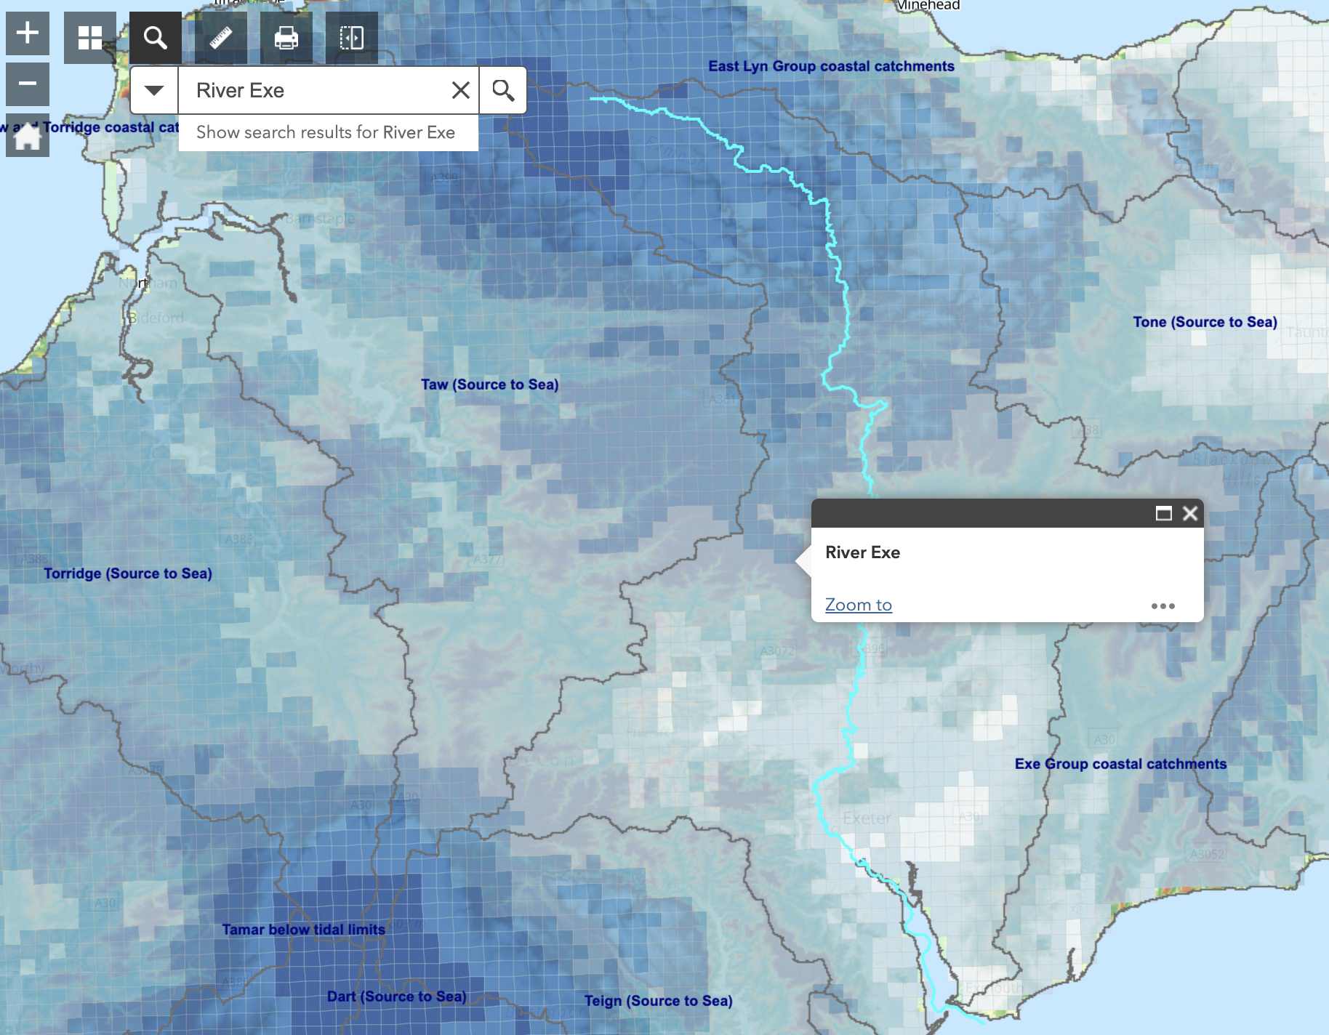
- Where in the catchment receives the highest amount of rainfall? What are some the rainfall values (in mm) in this area? Click on the map to find out.

_______________________________________________________________________

- Bonus Question: Why does this area have the highest rainfall in the catchment? Could this be linked to the terrain?

_______________________________________________________________________
_______________________________________________________________________
- Where in the catchment receives the lowest amount of rainfall? What are some the rainfall values (in mm) in this area? Click on the map to find out.

_______________________________________________________________________

- Turn off the Terrain and Rainfall layers (by unticking them in the layers list). Now turn on the ‘Landcover’ dataset. Your screen should look like the screenshot below.

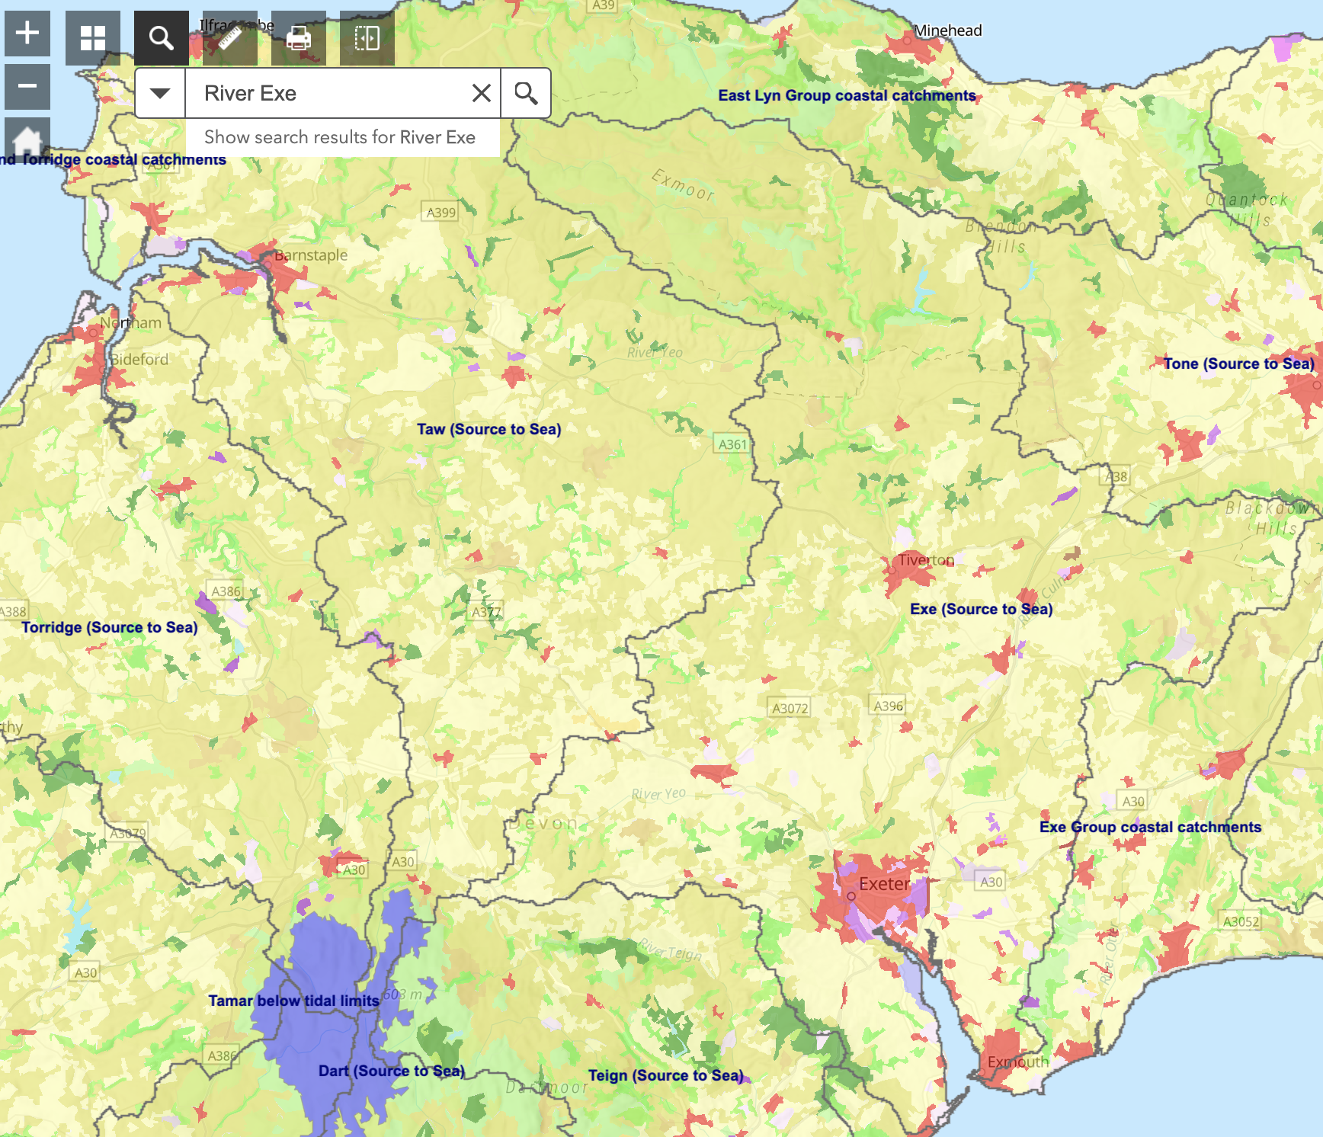

- Urban areas are coloured in shades of red and purple. What are the biggest urban areas in the Exe catchment called?

_______________________________________________________________________

_______________________________________________________________________
- What other types of landcover make up the Exe catchment? Click around the map to find out.

- _______________________________
- _______________________________
- _______________________________
- _______________________________
- _______________________________
- _______________________________
- Now turn off the landcover dataset and turn on the ‘Bedrock Geology’ dataset. Your screen should look like this:

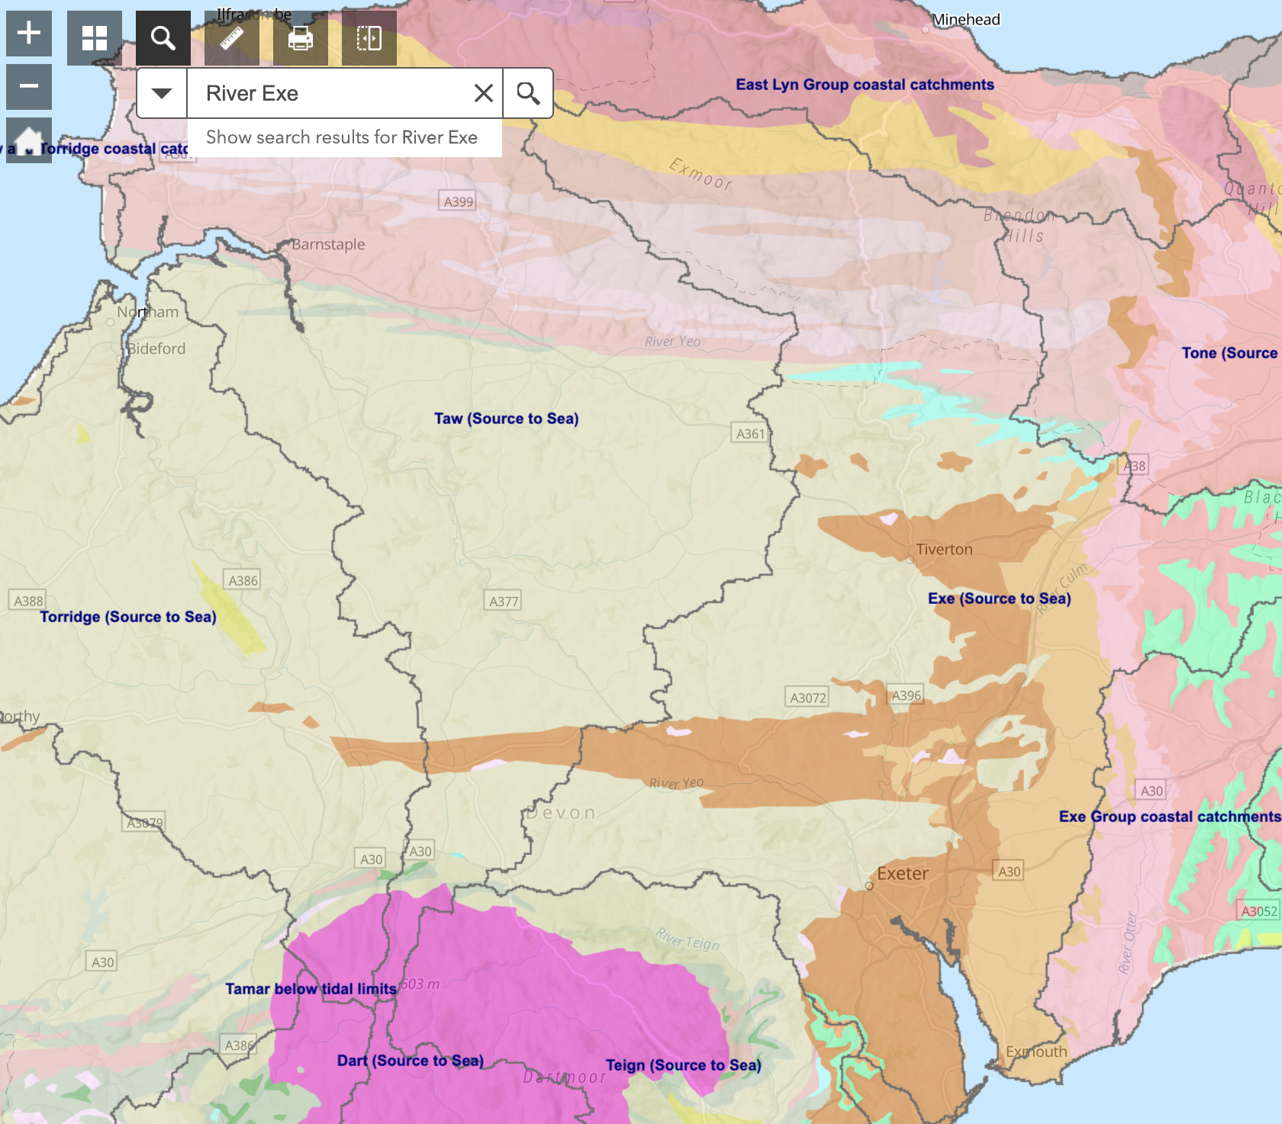

- You can see that the Exe catchment is made up of several different types of bedrock geology. Note down some of the most common rock types which make up the majority of the catchment below (most of the colours are variants of the same rock types).

- _______________________________
- _______________________________
- _______________________________
- _______________________________
- Turn off the geology dataset and turn on the ‘Population Density’ layer. Your screen should look like the screenshot below.

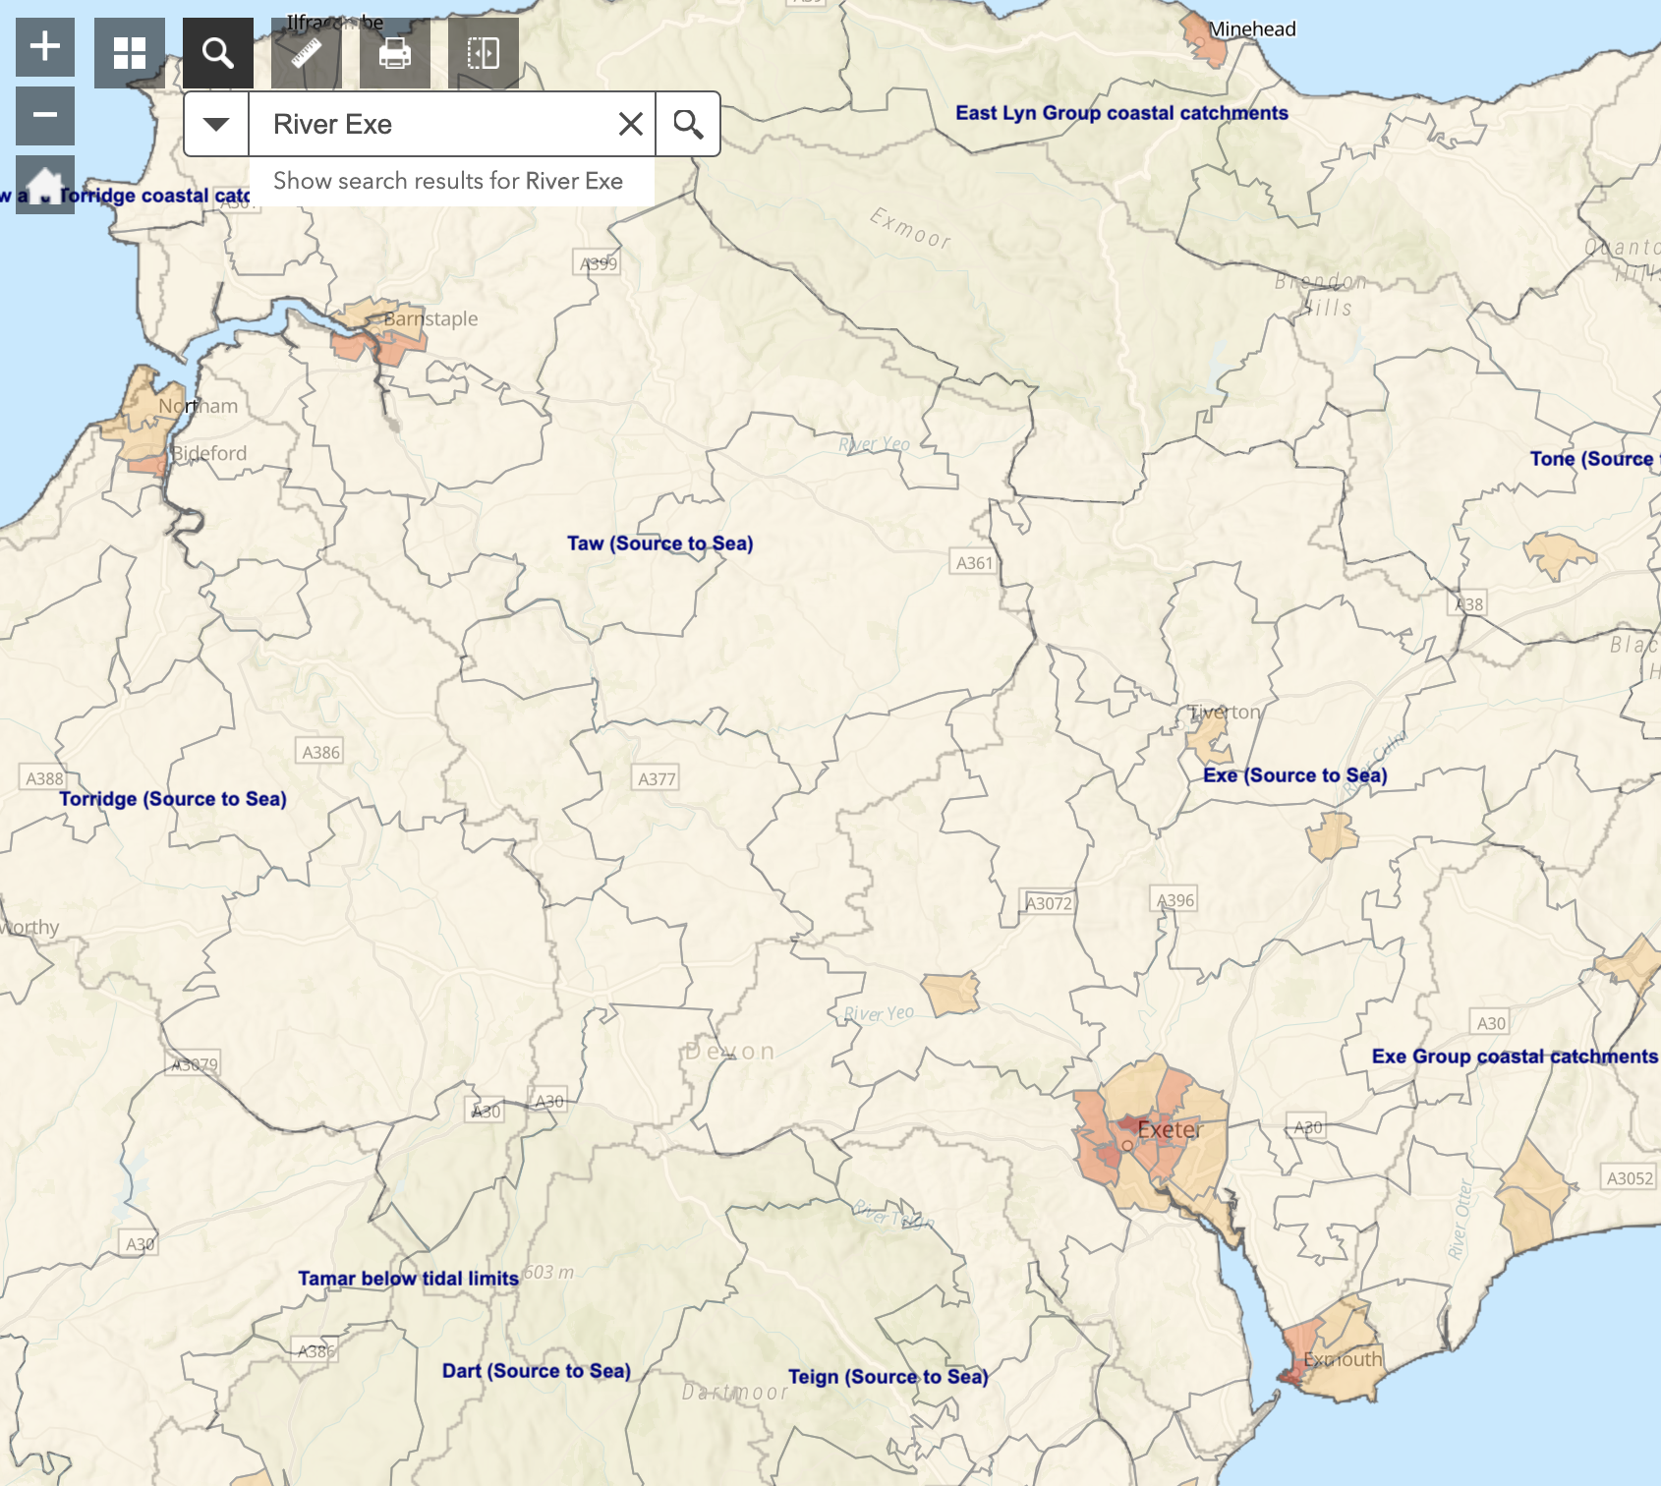
- Where has the highest population density in the Exe catchment?
_____________________________________________________________________

- Where has the second highest population density in the Exe catchment?

_____________________________________________________________________

- Finally we will explore areas at potential risk of flooding. Turn off the population density map. Then turn on ‘Terrain’ and ‘Risk of Flooding’. Your screen should look like this screenshot:

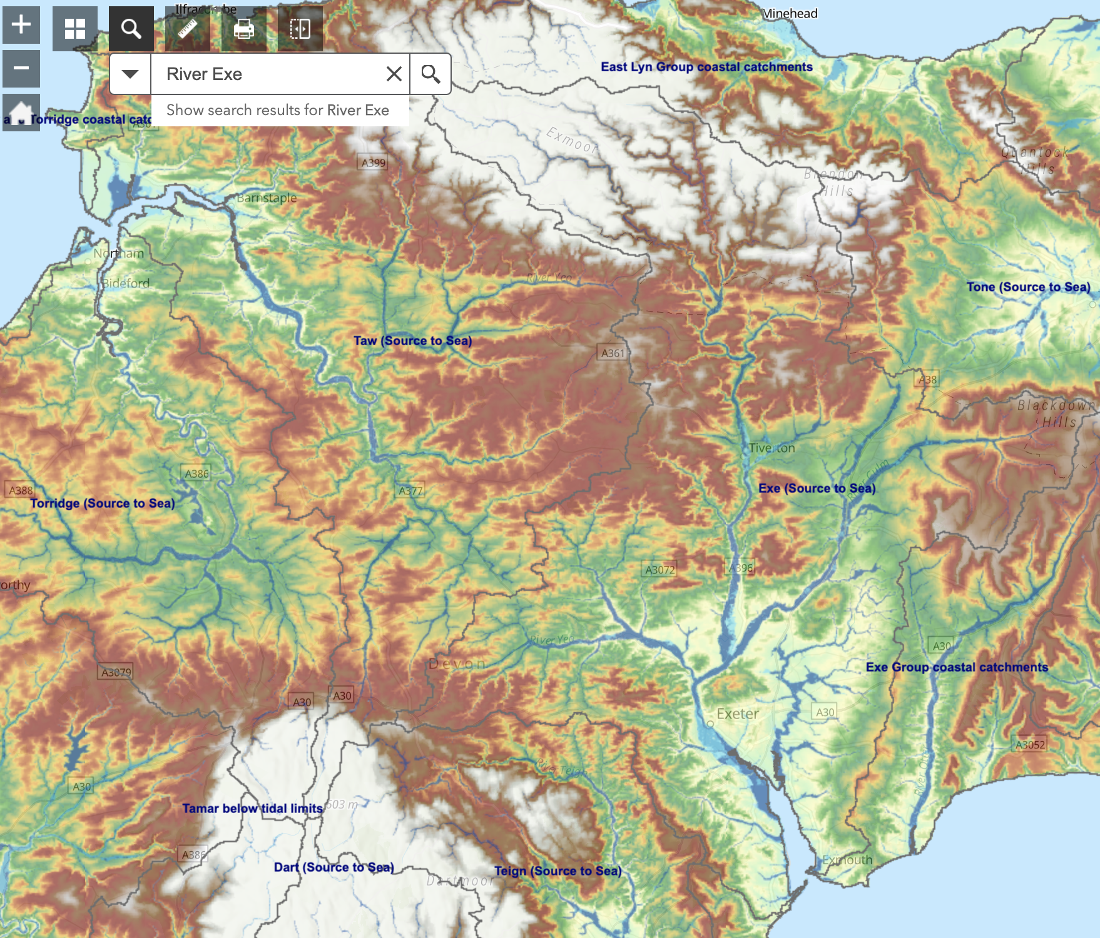

- Explore the catchment and fill in the blanks below.

The areas at the greatest risk of flooding can be found in the _________________ of the Exe catchment. Based on the population map this area also has the _______________ population density in the catchment.

We can see on the terrain map that this area is very _________________ and _______________. Expansive areas like this which are prone to flooding are called ______________________ and are typically found in the ______________ course of the river.

**Hints: Flat; Floodplains; Highest; Lower; South; Low-Lying**

- Based on all of the information you have collected in this activity write up a catchment profile of the Exe. Imagine you are describing it to someone who knows nothing about the Exe or the region. Make sure you describe all of its key characteristics (rainfall, terrain, population, landuse, geology, and flood risk).

_____________________________________________________________________
_____________________________________________________________________
_____________________________________________________________________
_____________________________________________________________________
_____________________________________________________________________
_____________________________________________________________________
_____________________________________________________________________
_____________________________________________________________________
_____________________________________________________________________
_____________________________________________________________________
_____________________________________________________________________
_____________________________________________________________________
_____________________________________________________________________
_____________________________________________________________________
_____________________________________________________________________
_____________________________________________________________________
_____________________________________________________________________
_____________________________________________________________________
_____________________________________________________________________
_____________________________________________________________________
_____________________________________________________________________
_____________________________________________________________________
_____________________________________________________________________
_____________________________________________________________________
_____________________________________________________________________

Do you want to learn more about catchment hydrology and river processes? As part of the BSc Geography degree at the University of the West of England (Bristol) you can study river/fluvial process, and how to manage river catchments and flood risk.

UWE Bristol Geography: https://courses.uwe.ac.uk/FF89/geography

Worksheet produced by Harry West (UWE Geography Department) (July 2020)

