Coastal Landforms GIS Activity

(Lulworth to Poole, South Coast)

In this short GIS activity you will explore coastal landforms along the Poole to Lulworth stretch of coastline in the south of the UK.

Part 1: Accessing the Explore South West Data Explorer

- To access the Explore South West Data Explorer head to the Geography South West webpage: https://www.geographysouthwest.co.uk/explore-sw/.
- Click the map image to open the Explorer in a full screen new tab.
- You can change the basemap using the icon in the top right hand corner of the map.

- Change the basemap to ‘Topographic’.
- Zoom into the stretch of coastline stretching from Lulworth to Poole Harbour – this is along the south coast of the UK. Your map should look like the below when you are done.

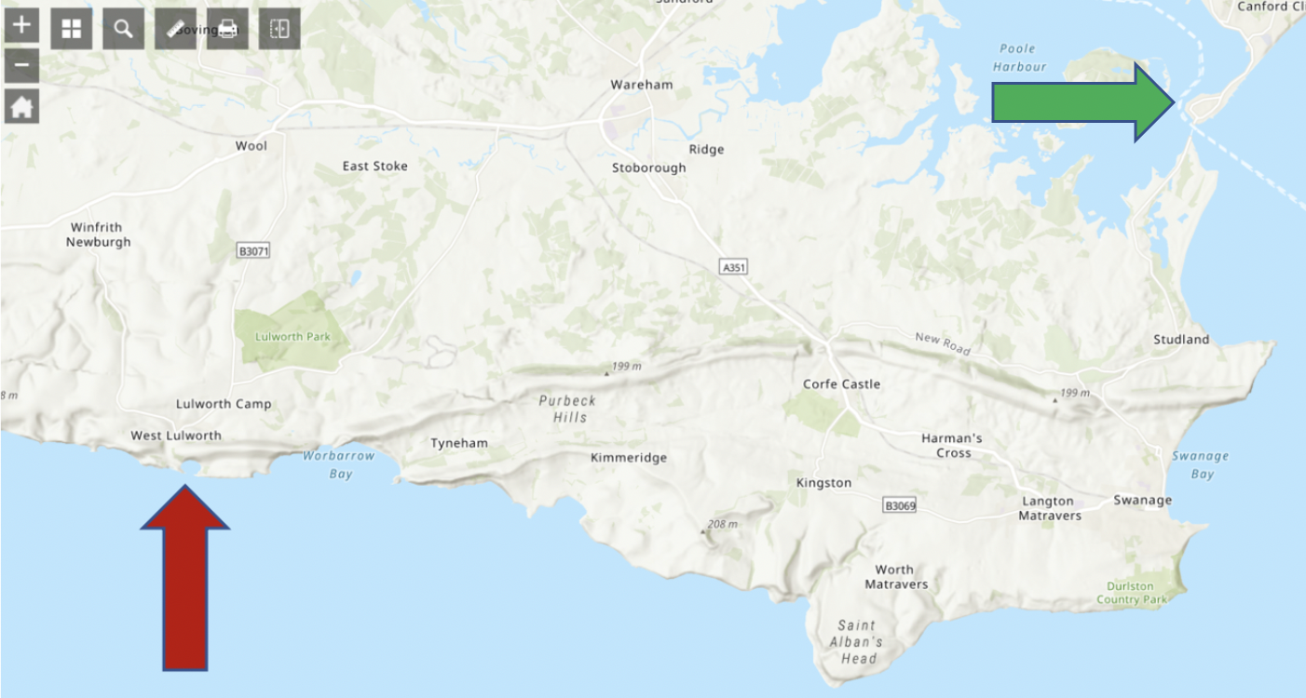

Part 2: Identifying Coastal Landforms

- Zoom into Lulworth – marked on the map above with a red arrow.
- What type of coastal landform is this?

______________________________________________________________________

- Work your way along the coastline until you get to the entrance to Poole Harbour (marked with a green arrow on the map above). As you do switch between the ‘Topographic’ and ‘Imagery’ basemaps. Can you identify 6 different coastal landforms from this maps:

  - _______________________________________________________________
  - _______________________________________________________________
  - _______________________________________________________________
  - _______________________________________________________________
  - _______________________________________________________________
  - _______________________________________________________________

Part 3: Exploring Coastal Geology

- Zoom out to the full Lulworth-Poole extent of the map again. Now using the layers list on the left hand side of the screen, activate the ‘South West Bedrock Geology’ layer. You do this by ticking the box next to it.

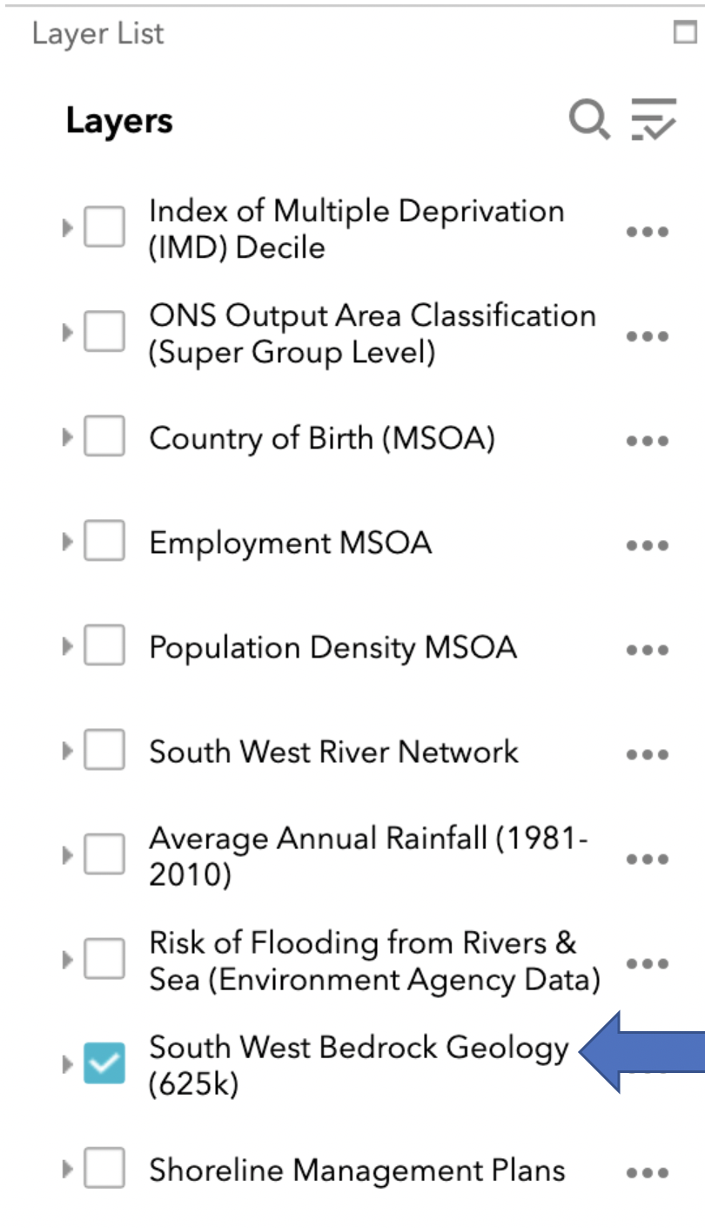
- You can now see that this section of the coast has quite distinctive and clear underlying bedrock geology. Take a moment to explore the geology of this section of the coast – you can get more information by clicking on the rock and reading the ‘pop’ up.

- Fill in the blanks below:

Coastlines which have a generally similar geology along their length are called __________________ coastlines. This is shown on the map along the __________________coastline from Worbarrow Bay to Durlston Country Park.

Whereas coastlines with have alternative bands of geology (strata) are called __________________ coastlines. This is shown along the _____________________ coastline from Durlston Country Park to Poole Harbour.

**Hints: Discordant, East-West, North-South, Concordant**

- Zoom into the Studland headland on the North-South section of this coastline (shown on the map below).

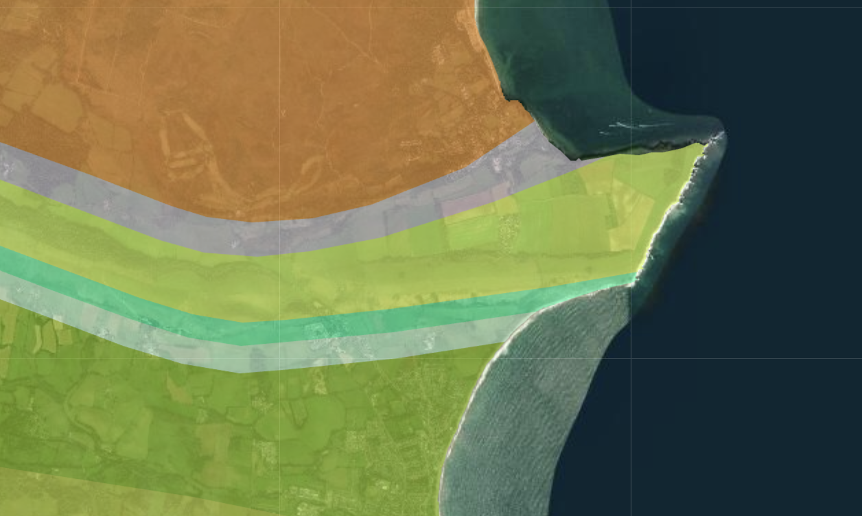

- What type of rock forms the Studland headland (click on the rock to find out).

______________________________________________________________________

- Using the satellite imagery basemap what distinctive colour is this rock?

______________________________________________________________________

- Using Google, can you find out what the name of this famous headland is?

______________________________________________________________________

- What types of rock are found in the north and south bays surrounding the headland?

______________________________________________________________________

- Using the geological information you have gathered in Questions 13-16 above describe and explain the formation of the Studland headland.

______________________________________________________________________

______________________________________________________________________

______________________________________________________________________

______________________________________________________________________

______________________________________________________________________

______________________________________________________________________

______________________________________________________________________

______________________________________________________________________

______________________________________________________________________

______________________________________________________________________

______________________________________________________________________

______________________________________________________________________

- Can you draw a diagram which explains your answer to Question 17 above?

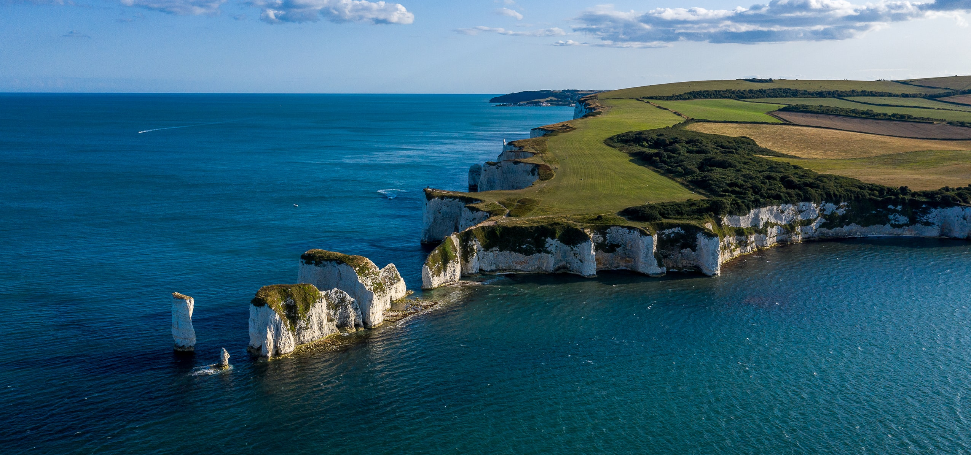

Do you want to learn more about coastal landforms and processes? As part of the BSc Geography degree at the University of the West of England (Bristol) you can study coastal processes, and how to manage the ever changing coastline.

UWE Bristol Geography: https://courses.uwe.ac.uk/FF89/geography

Worksheet produced by Harry West (UWE Geography Department) (July 2020)

