Investigating rainfall in the South West: a KS3 GIS activity
Figure 1 shows the annual average rainfall in the UK.
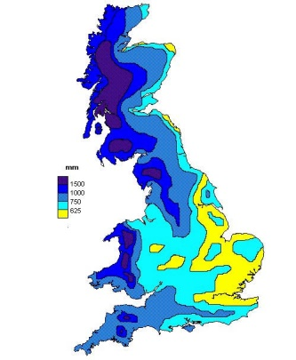
Figure 1

https://www.british-towns.net/weather/uk-annual-rainfall
- Write a label to locate the South West region
- Describe the areas of the UK experiencing the highest annual average rainfall. Add labels to identify some of these areas/regions.
------------------------------------------------------------------------------------------------------------------------------------------------------------------------------------------------------------------------------------------------------------------------------------------------------------------------------------------------------------------------------------------------------------------
Notice that in the South West there are two distinctive areas with very high rainfall. Let’s investigate why.
Access the Explore SW page on the geography southwest website (www.geographysouthwest.co.uk) and click the interactive map. This will reveal the following:
These icons enable you to zoom, search, measure or print

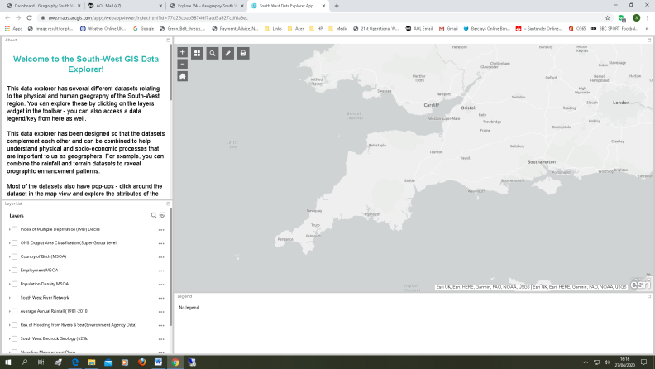
Introduction
Base map

The key will appear here when you apply a layer

Data sets (layers)

Basemap
Click the Basemap Gallery to reveal the options available to you
Click the topographic option to show the location of the region’s uplands (shaded green).
- Can you identify the names of the two uplands identified? You will need to use the internet to help you with one of them!

Let’s see if there is any connection between these two uplands and rainfall.
On Explore SW, find Average Annual Rainfall in the list of layers. Click the box.
This is what you should see next!
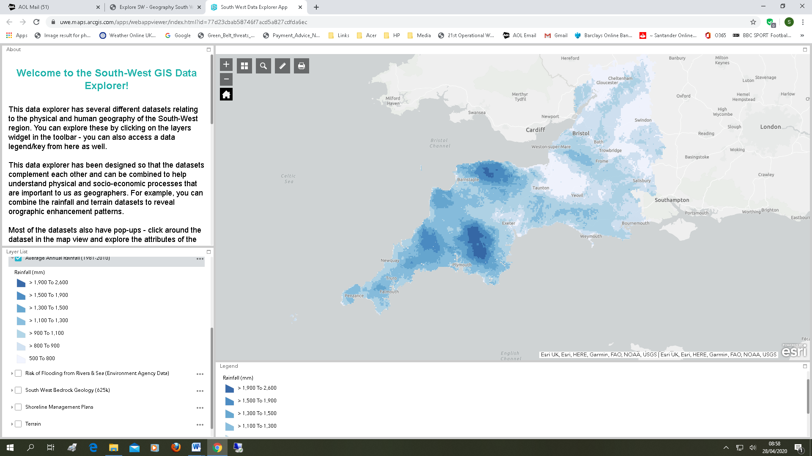
Look at the colour key. Notice that the darker the blue colour, the higher the average annual rainfall.
- What do you notice about the areas of highest average annual rainfall in relation to the two uplands identified in Question 3?
----------------------------------------------------------------------------------------------------------------------------------------------------------------------------------------------------------------------------------------------------------------------------
- Look at the interactive map showing average annual rainfall. Compare the rainfall in the west of the South West with that of the east.
----------------------------------------------------------------------------------------------------------------------------------------------------------------------------------------------------------------------------------------------------------------------------
Let’s now look at the data on the map.
Locate Dartmoor National Park to the northeast of Plymouth.
Use the zoom icon (or roller on your mouse) to zoom-in to Dartmoor National Park.
Left click on the map to reveal average annual rainfall data recorded for the dark blue area (highest rainfall). Notice that values are over 2,000mm. Can you find a value over 2,500mm?
- Let’s calculate an average value for Dartmoor. To do this, randomly click 5 locations on Dartmoor National Park (dark blue). Record you values in the table below.

Point | Rainfall (mm)
1
2
3
4
5
TOTAL

Divide the total by 5 to calculate an average value for Dartmoor National Park.
Total _______ mm / 5 = _______ mm

- Now use the interactive map to find the rainfall values for the following places:

Location | Rainfall (mm)
Plymouth
Exeter
Taunton
Bristol
Gloucester

- Calculate the difference in rainfall between Dartmoor (your average figure) and Gloucester.
Dartmoor average ( ____ mm) – Gloucester ( ____ mm) = ______ mm

In conclusion
- On Figure 1, what are the names of the two upland areas in the South West?
Area 1 ___________________ Area 2 _____________________
- Do the uplands of the South West experience higher or lower average annual rainfall than the lowlands? Higher/Lower

Extension
Use the internet to find out why upland areas such as Dartmoor National Park experience very high rainfall totals. Look up ‘relief rainfall’ to get you started. Try to find a diagram to help you explain how relief rainfall occurs.

